

Pat project

Design document



Bryce grahn 12 key 1

Table of Contents

Game: 2

Summary: 2

User Interface – Forms and report: 3

Sequencing (Flowchart in Visio) 15

Classes and internal data storage structures: 20

Text file and database: 24

Reason for storage plan 26

Test Plan: 26

# Game:

Eat It

# Summary:

EAT IT: A Snake constantly moves around the board. The player controls the direction the "head" of the snake moves; either up, down, left or right in a 2D playing field. The snake must try to eat apples that randomly appear on the screen. The player does this by hitting the apple with the snake’s head. Eating an apple causes the snake to grow in length, one unit at a time. The game ends if the snake crashes into the edge of the board, itself or random blocks that may appear and the number of lives is reduced to zero. As the game progresses the player may obtain power ups by eating special apples that slow the speed, gain a bonus life, earn double points for 20 seconds or obtain invincibility for 20 seconds. The user has the option at the beginning of the game to select the help, play, difficulty or exit option. With a change in difficulty leads to different game layouts, quicker speeds and additional objects that the player must dodge.

# User Interface – Forms and report:

Main Interface

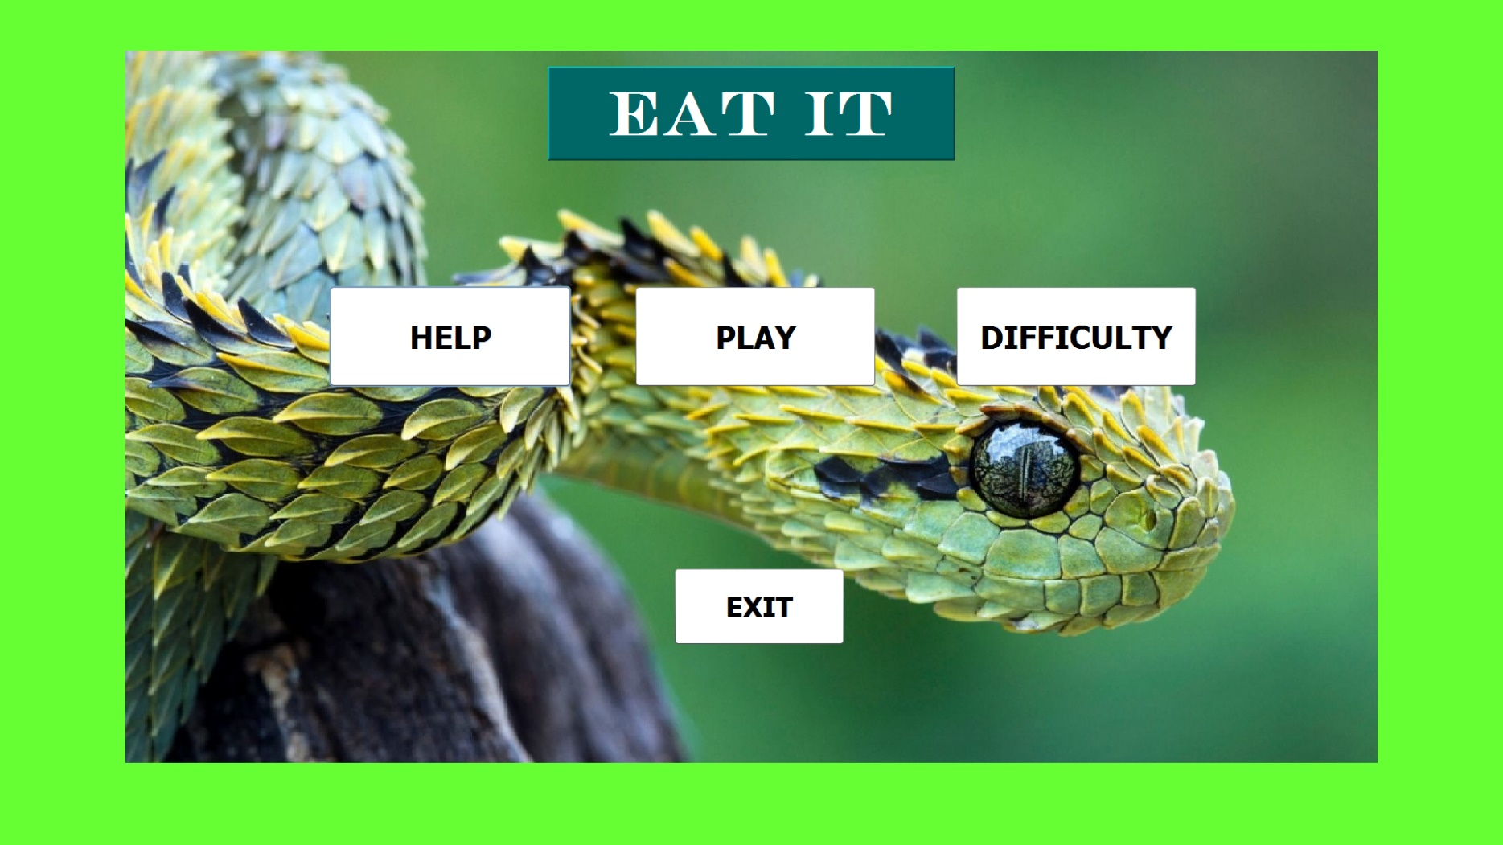

Action:

Play: Closes this interface and opens the game interface

Help: Closes this interface and fetches data from a text file and displays it on the help interface

Difficulty: Closes this interface and opens the difficulty interface

Exit: Closes this interface

Difficulty interface

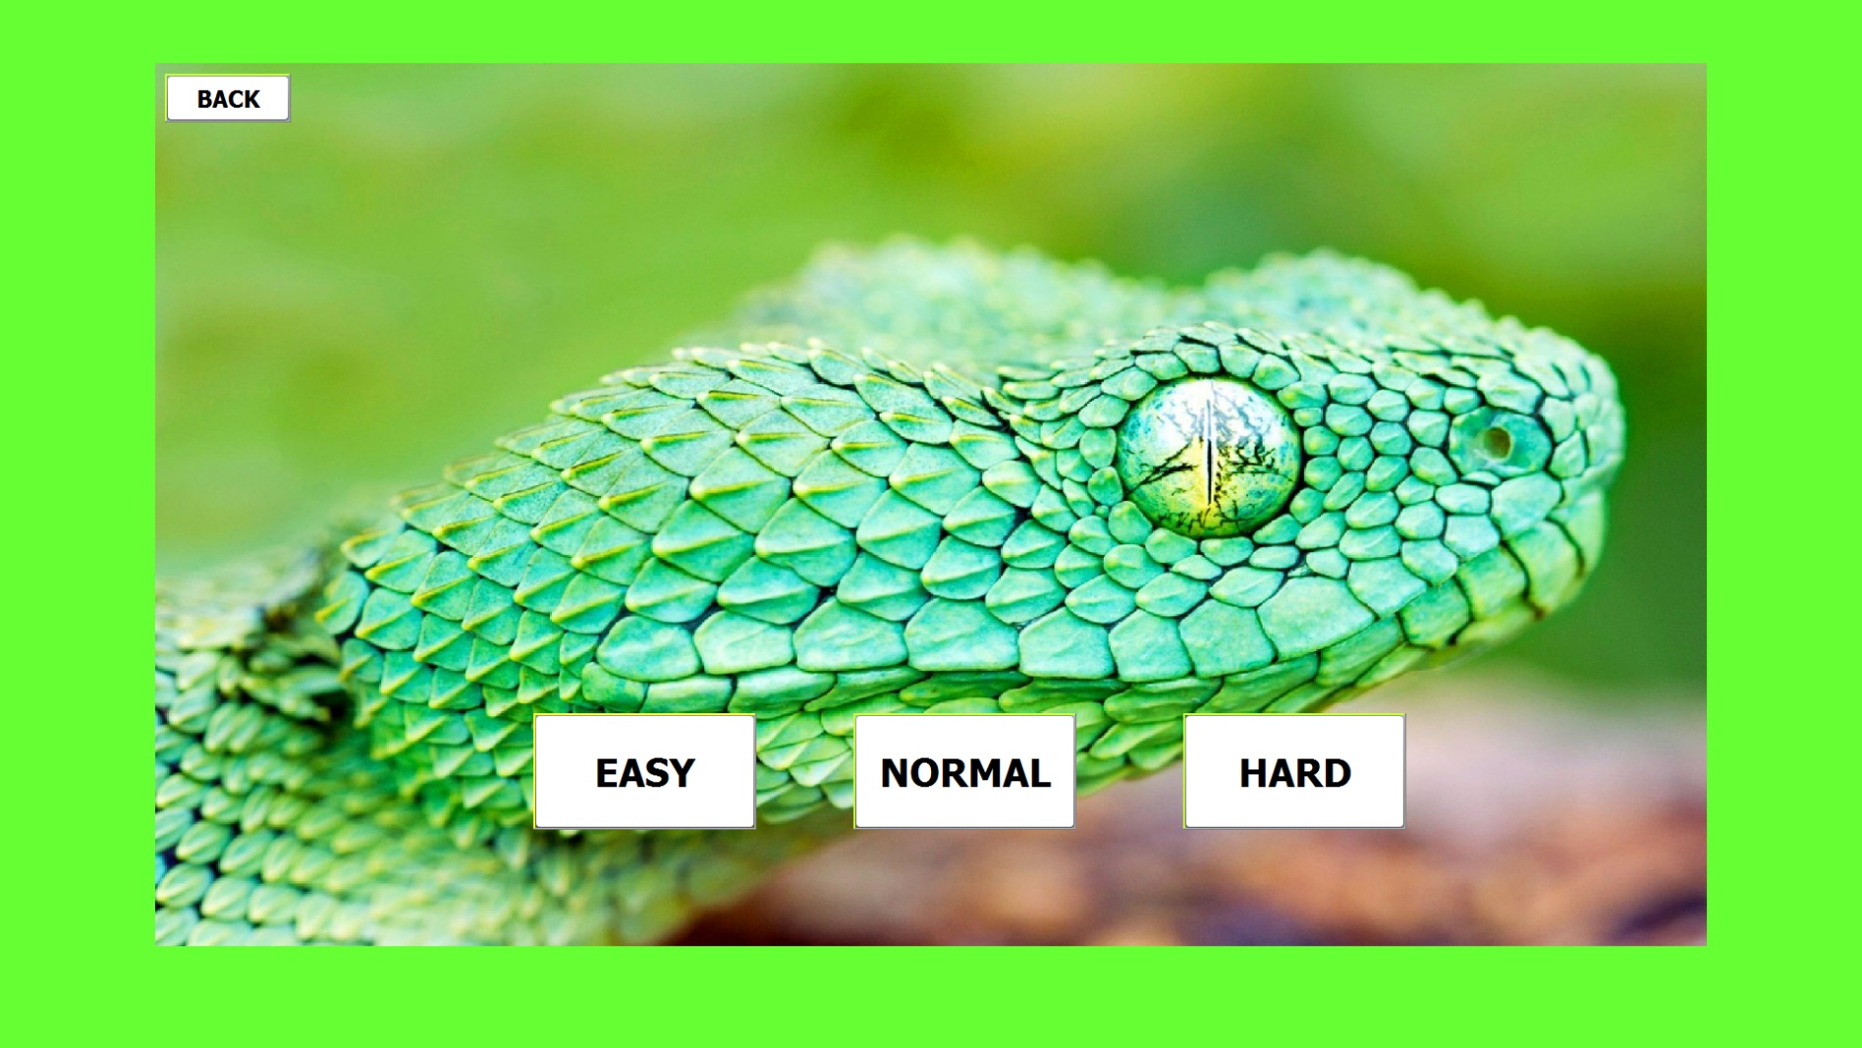

Action:

Easy: Closes this interface, changes program settings to easy mode, opens the main interface

Normal: Closes this interface, changes program settings to normal mode, opens the main interface

Hard: Closes this interface, changes program settings to Hard mode, opens the main interface

Back: Closes this interface and opens the main interface

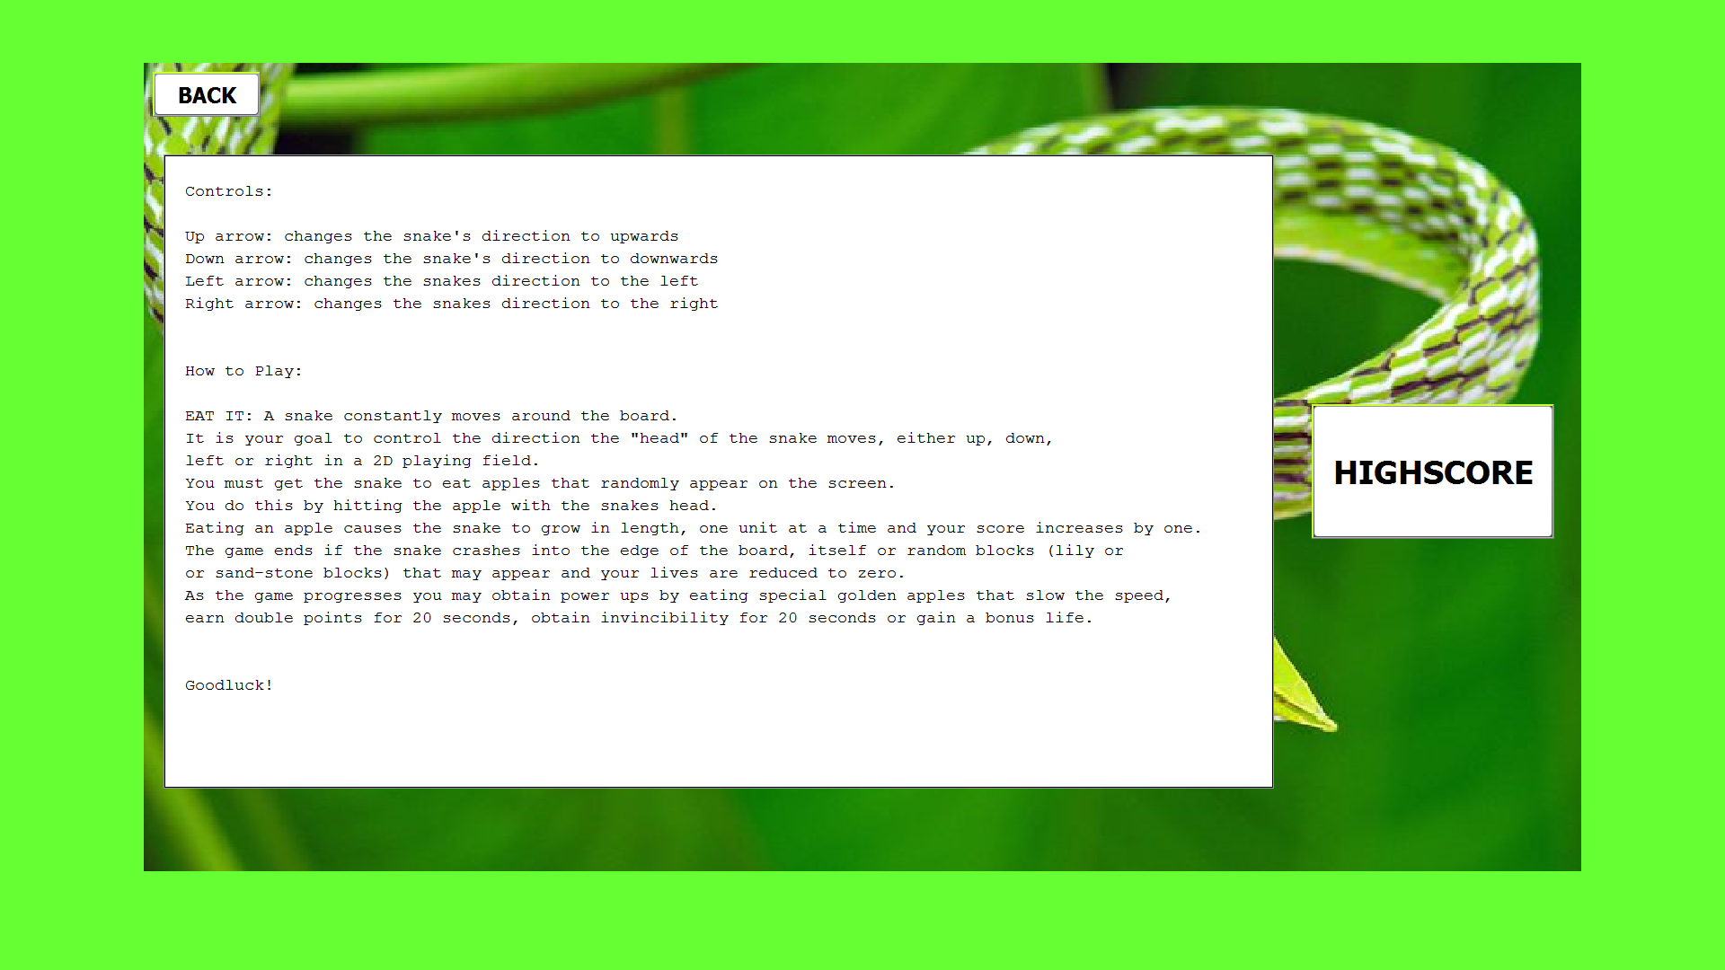

Help interface

Action:

High Score: Closes this interface and opens the select high score interface

Back: Closes this interface and opens the main interface

Select High score interface

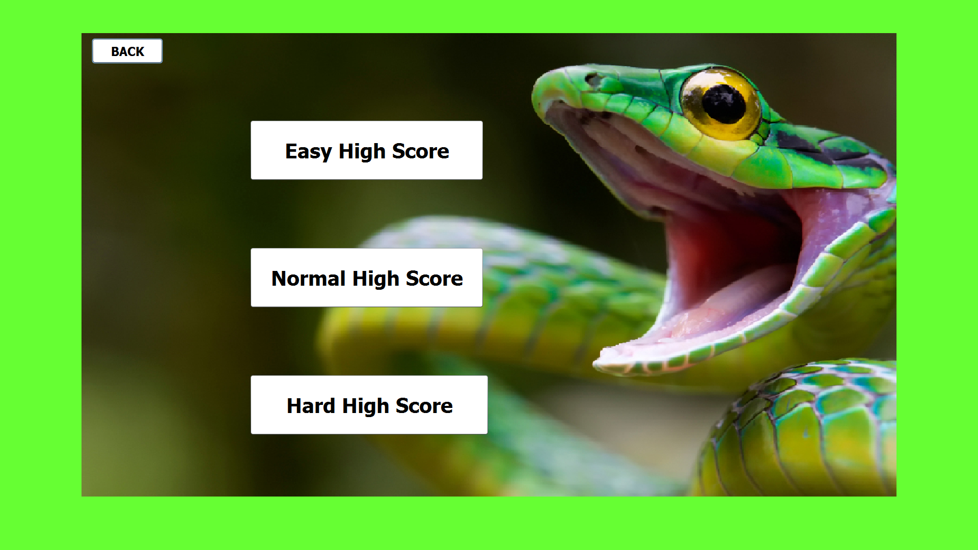

Action:

Back: closes this interface and opens the help interface

Easy High Score: Closes this interface, fetches top 20 easy scores and names from a database and then opens and displays it on the Easy High Score interface.

Normal High Score: Closes this interface, fetches top 20 normal scores and names from a database and then opens and displays it on the Normal High Score interface.

Hard High Score: Closes this interface, fetches top 20 hard scores and names from a database and then opens and displays it on the Hard High Score interface.

Highscore interface

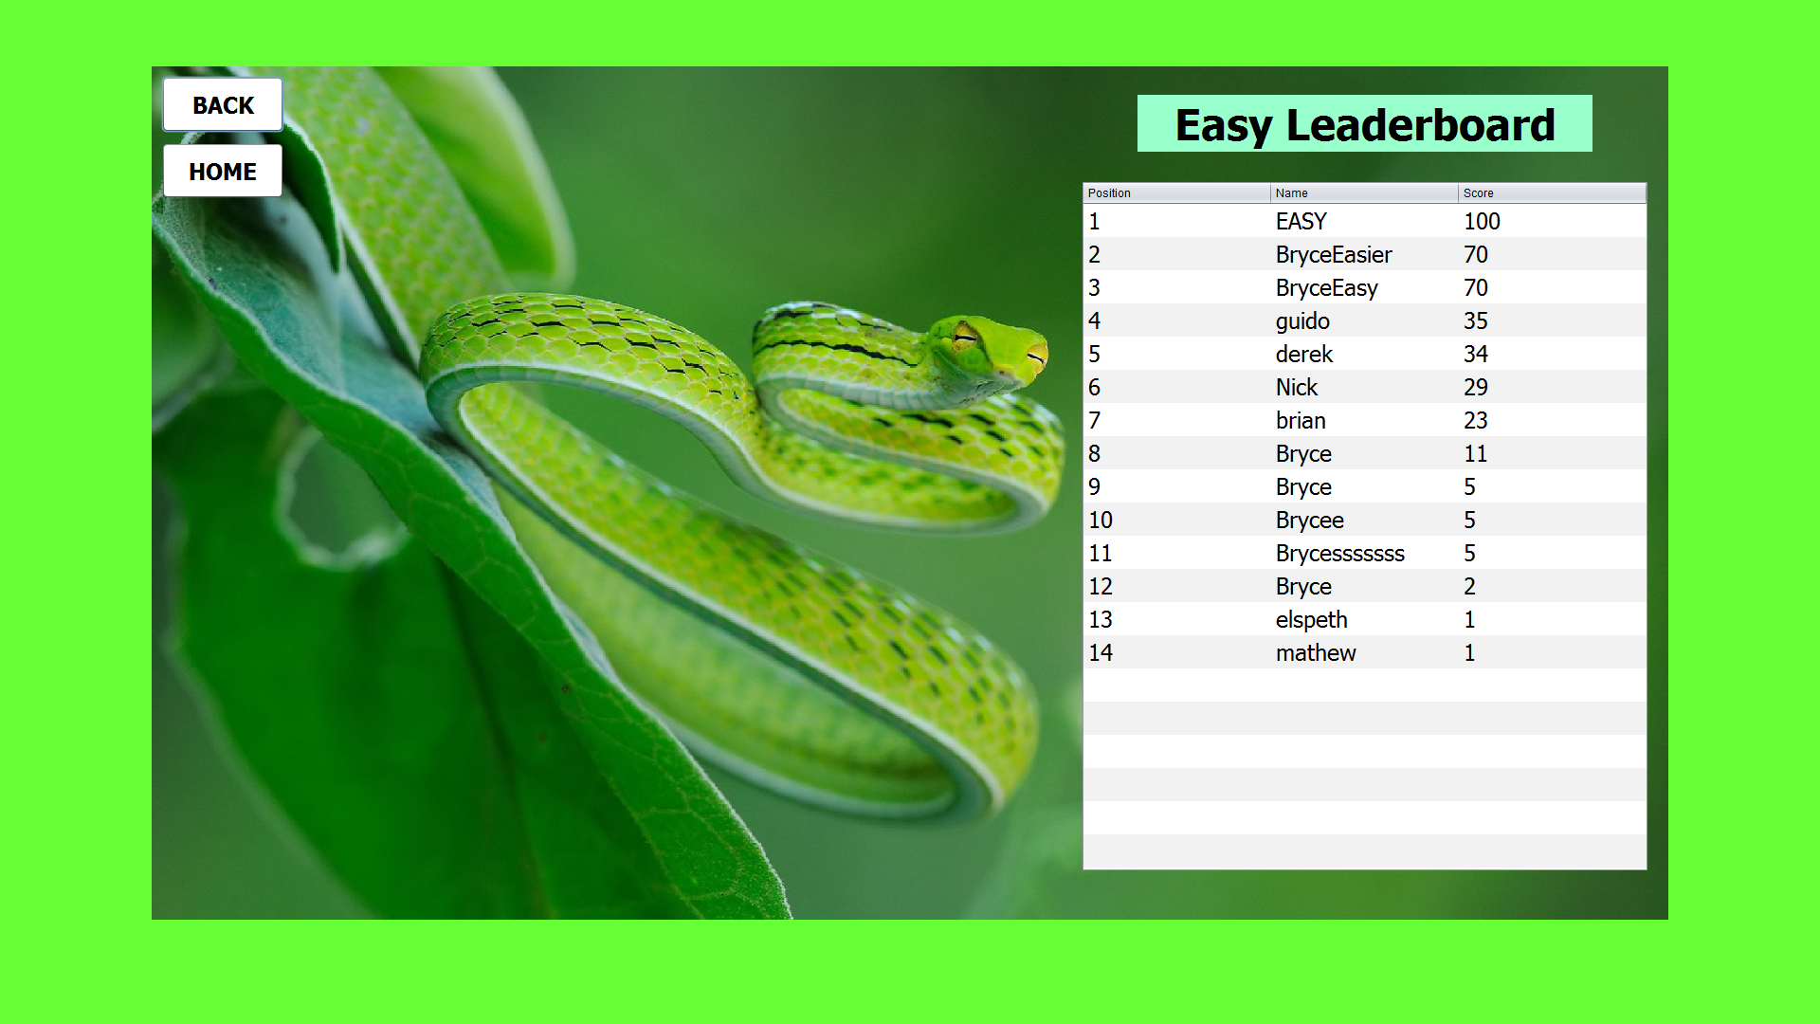Easy:

Action:

Back: closes this interface and opens the select high score interface

Home: closes this interface and opens the main interface

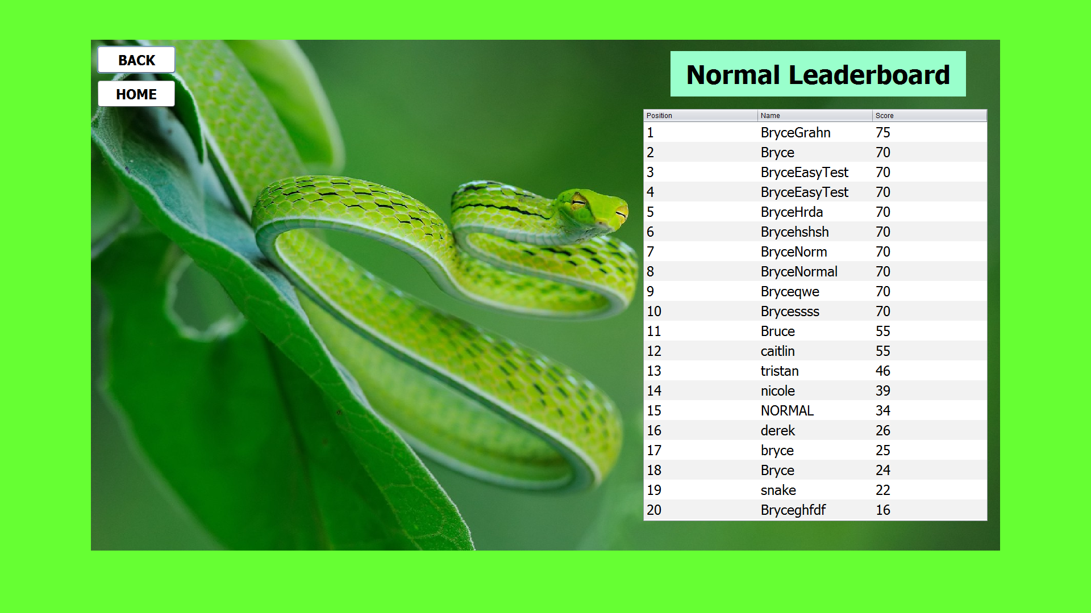Normal:

Action:

Back: closes this interface and opens the select high score interface

Home: closes this interface and opens the main interface

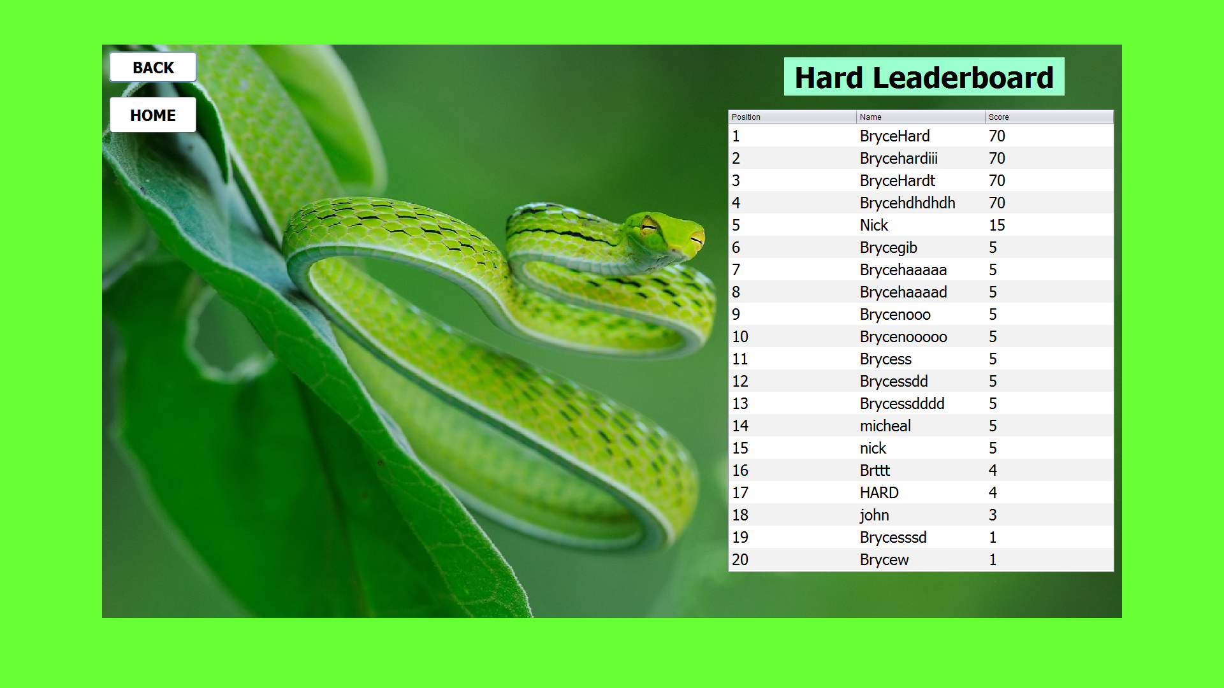Hard:

Action:

Back: closes this interface and opens the select high score interface

Home: closes this interface and opens the main interface

Game interface

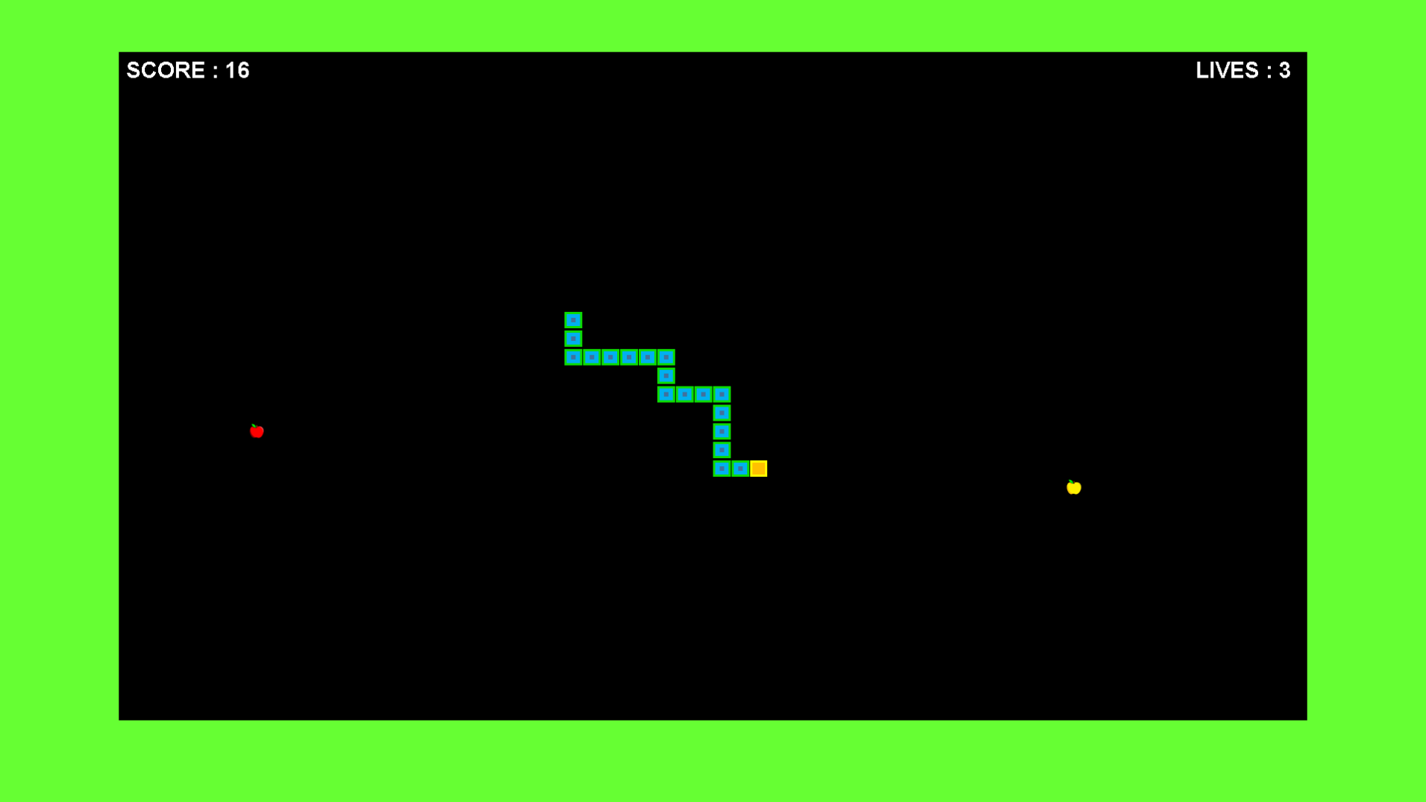Easy:

Action:

Game over: Opens the score option interface

Up arrow: changes snake’s direction to up

down arrow: changes snake’s direction to down

left arrow: changes snake’s direction to left

right arrow: changes snake’s direction to right

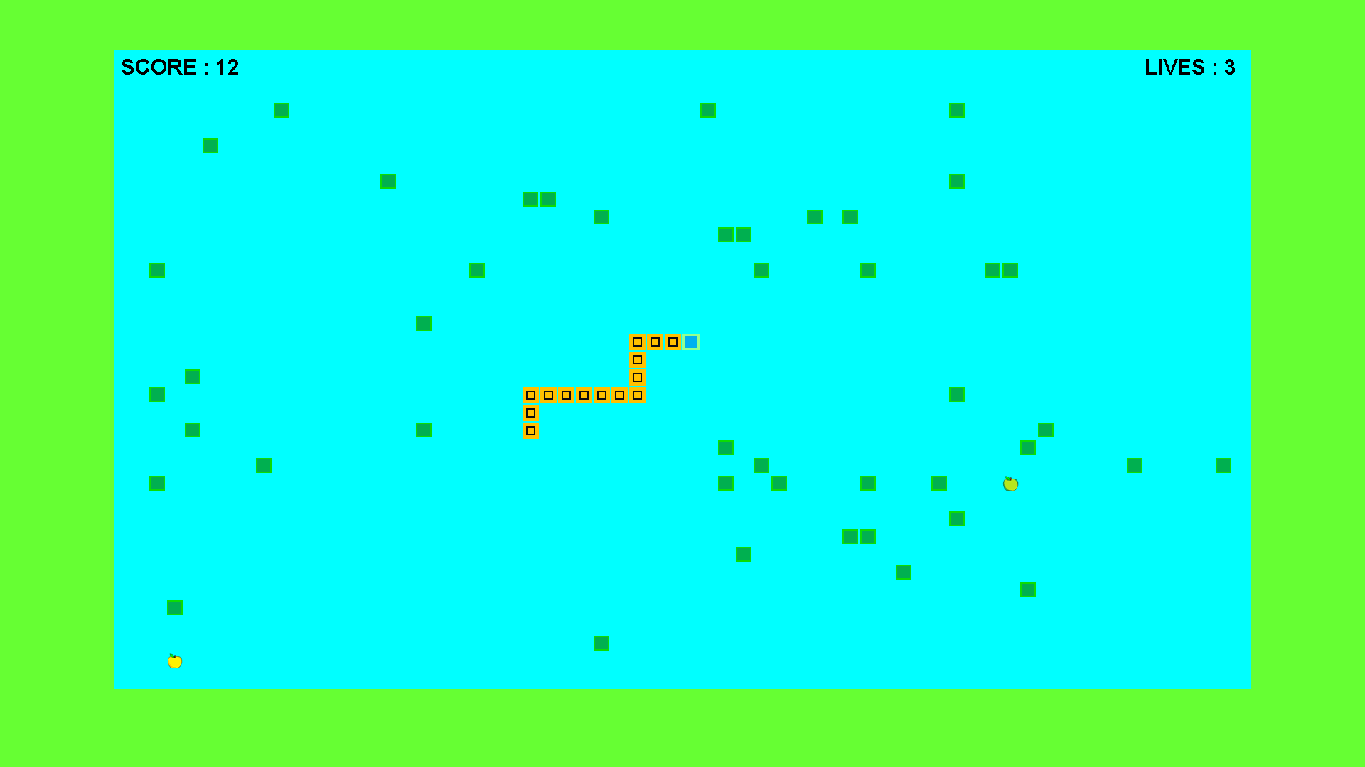Normal:

Action:

Game over: Opens the score option interface

Up arrow: changes snake’s direction to up

down arrow: changes snake’s direction to down

left arrow: changes snake’s direction to left

right arrow: changes snake’s direction to right

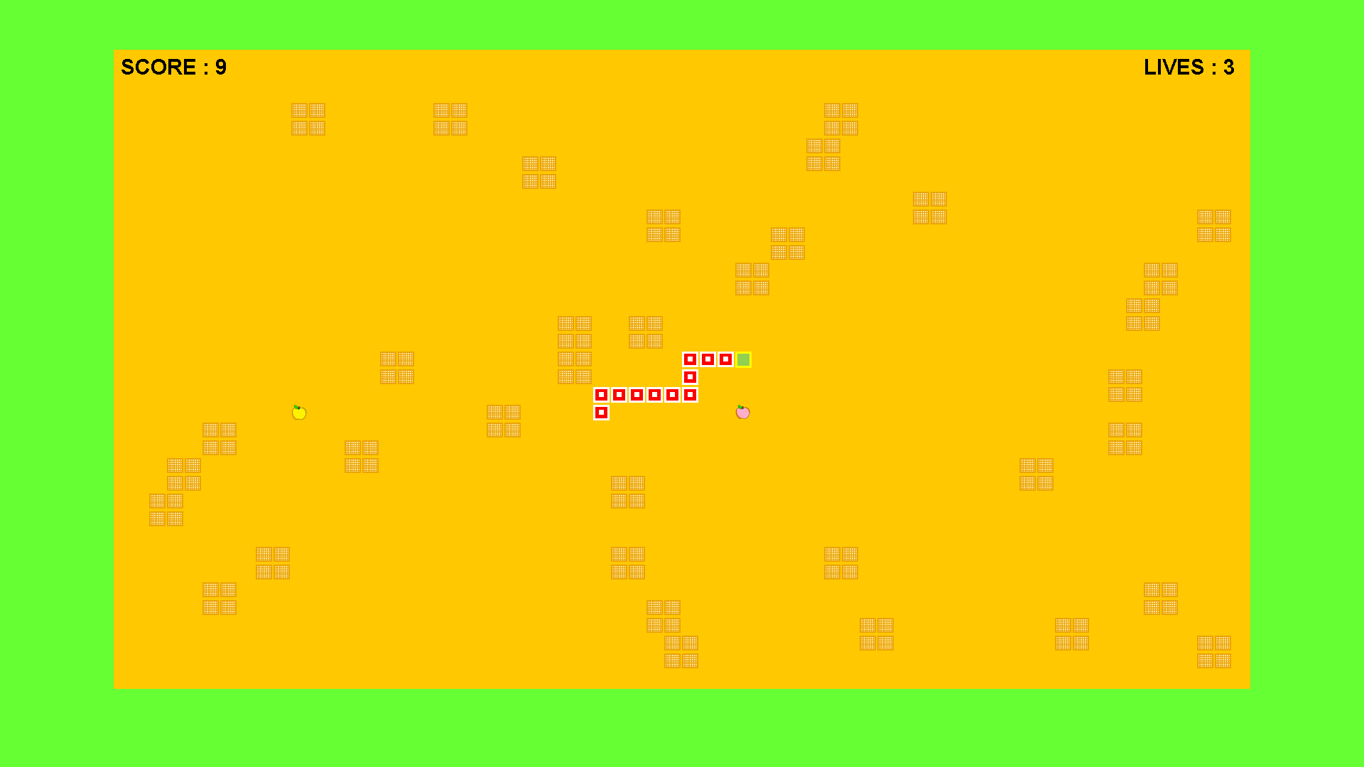Hard:

Action:

Game over: Opens the score option interface

Up arrow: changes snake’s direction to up

down arrow: changes snake’s direction to down

left arrow: changes snake’s direction to left

right arrow: changes snake’s direction to right

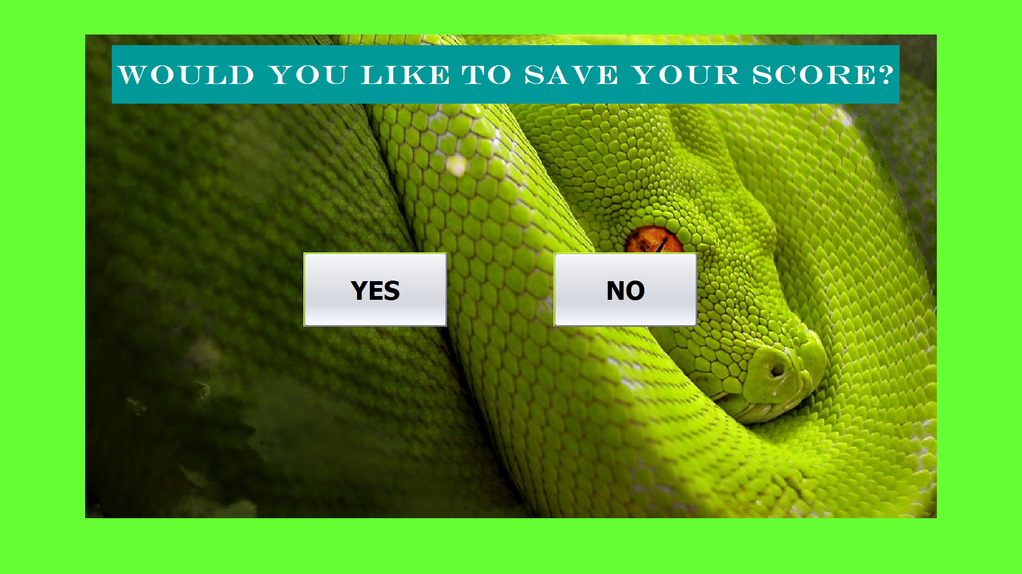

Score option interface

Action:

Yes: Closes score option interface and opens the Score interface

No: Closes score option interface and the playing field interface and then opens the main interface

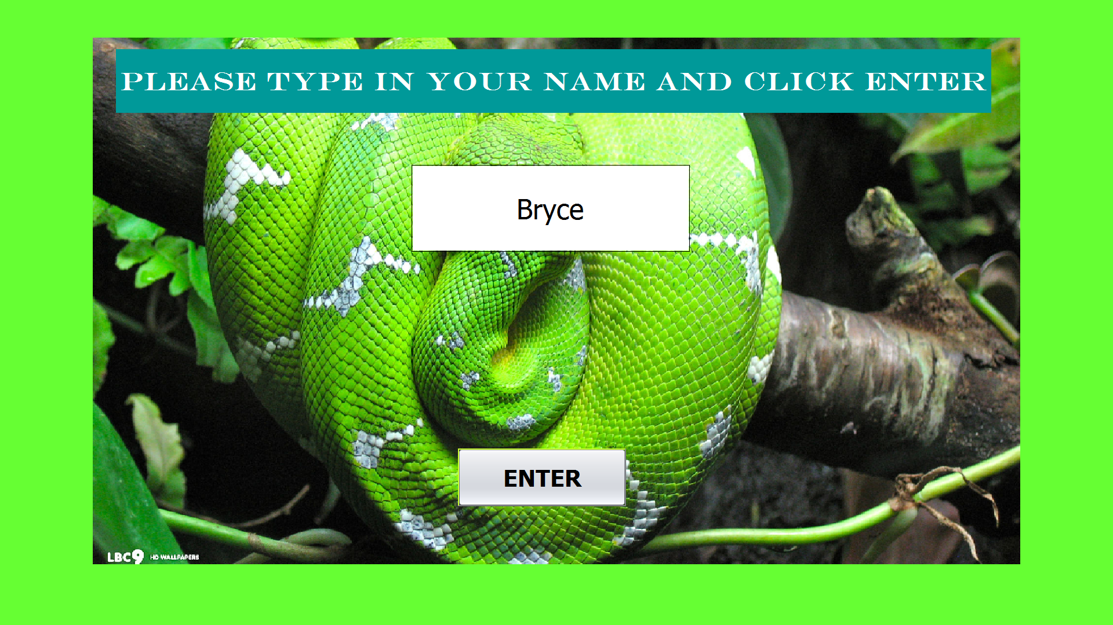

Score interface

Action:

Enter: Closes score interface, updates database with score and name, closes the playing field interface and opens the main interface

# Sequencing (Flowchart in Visio)

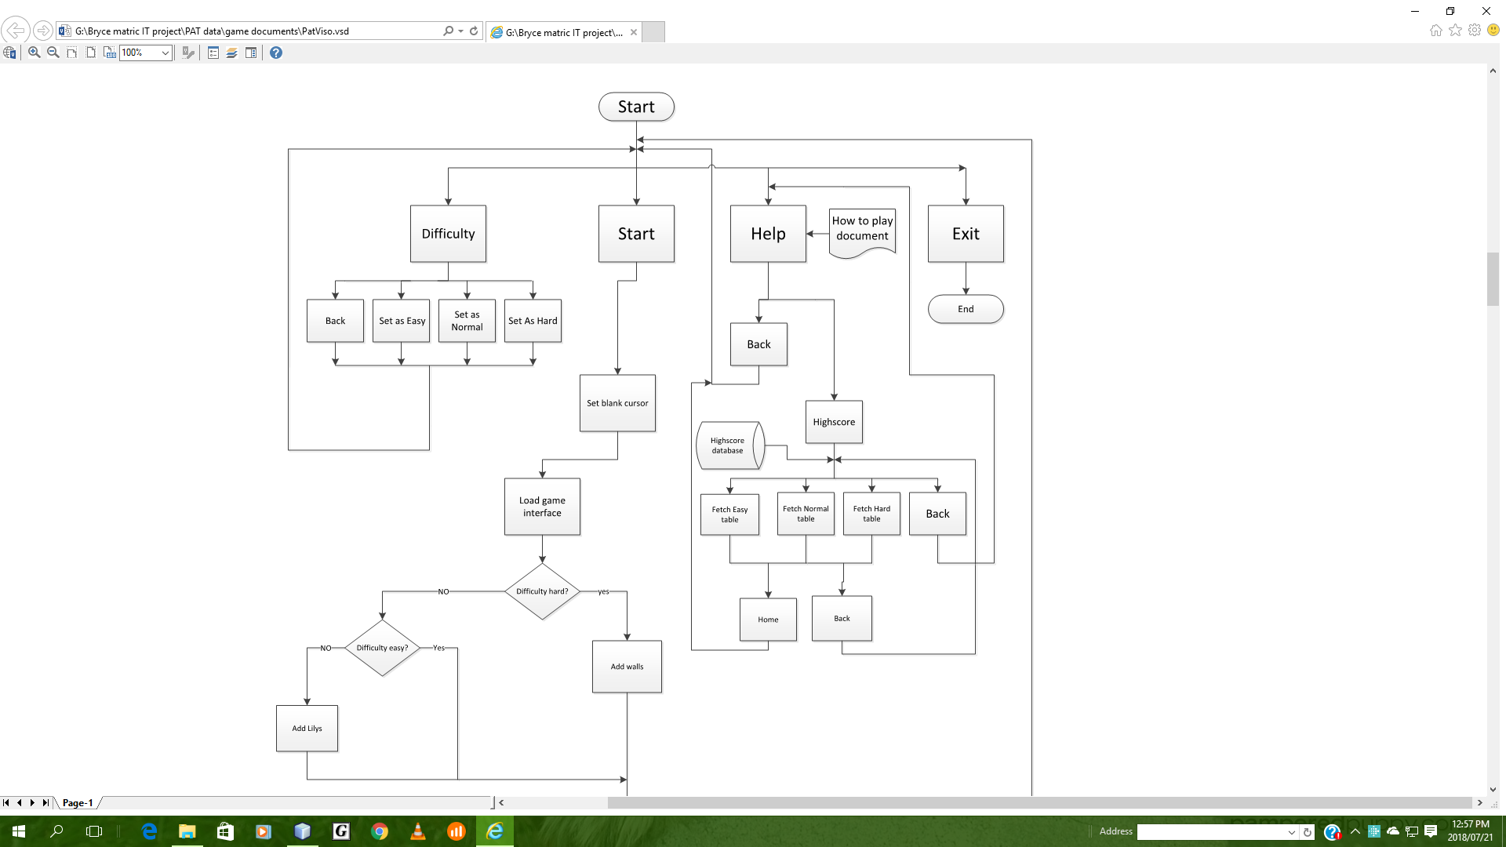

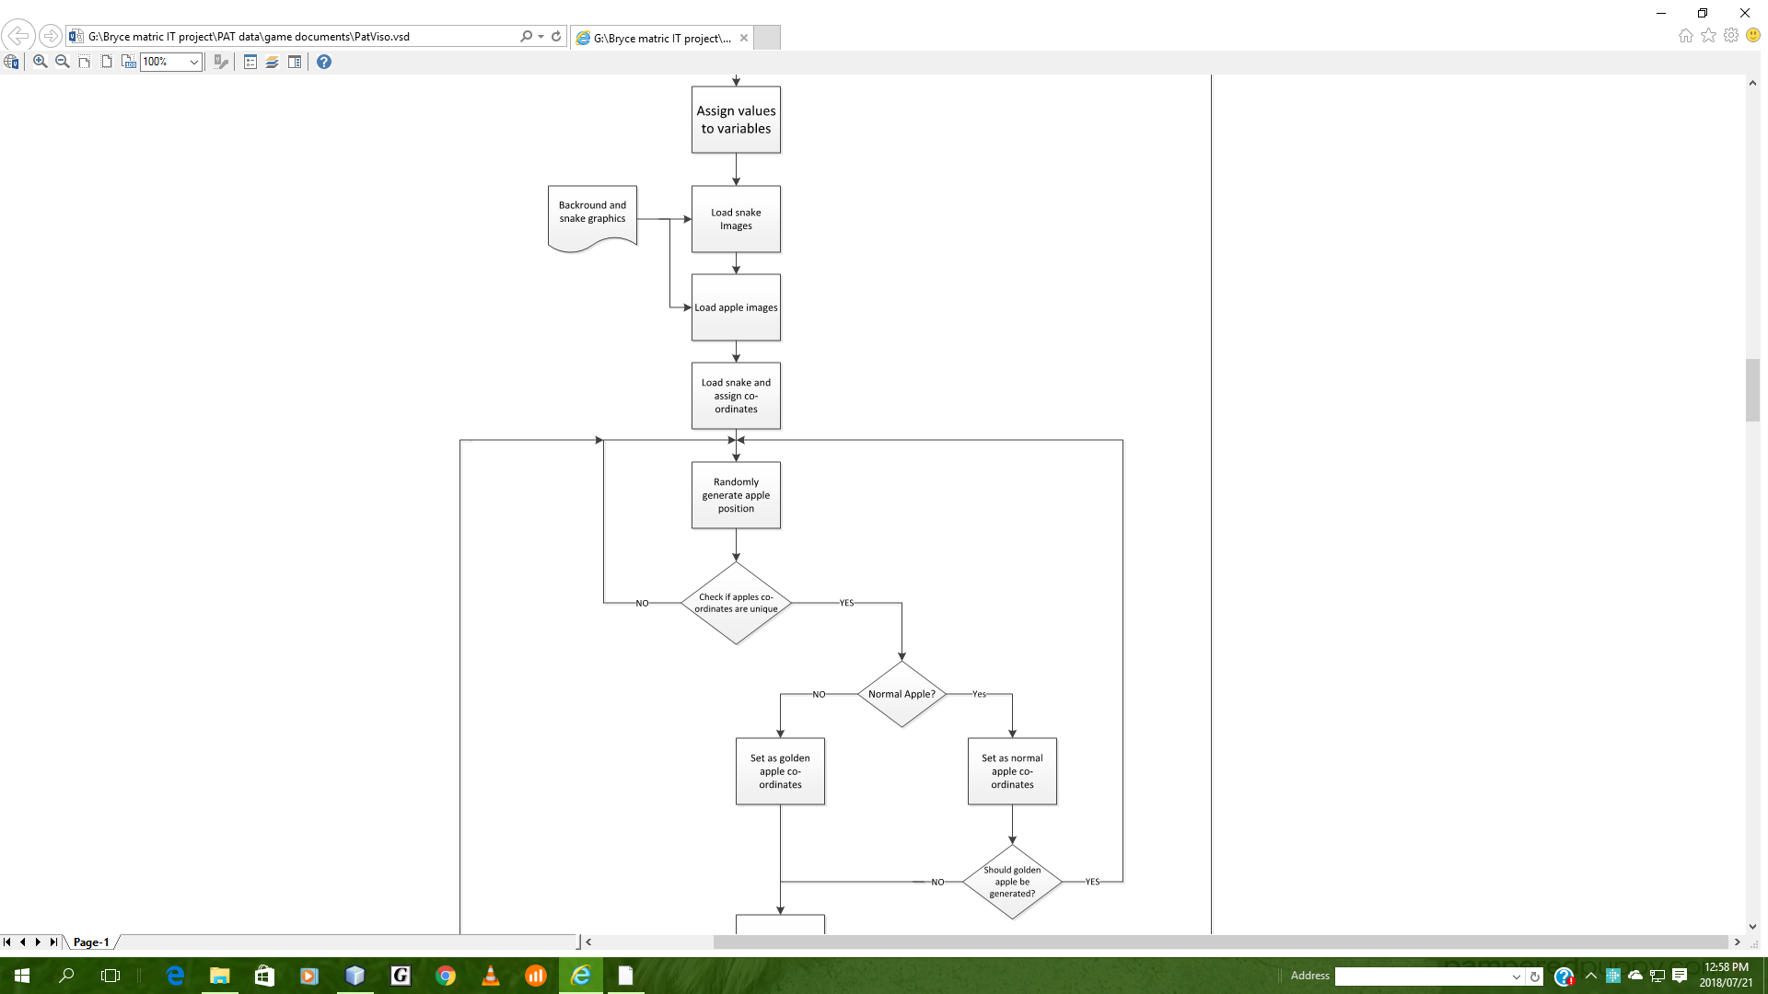

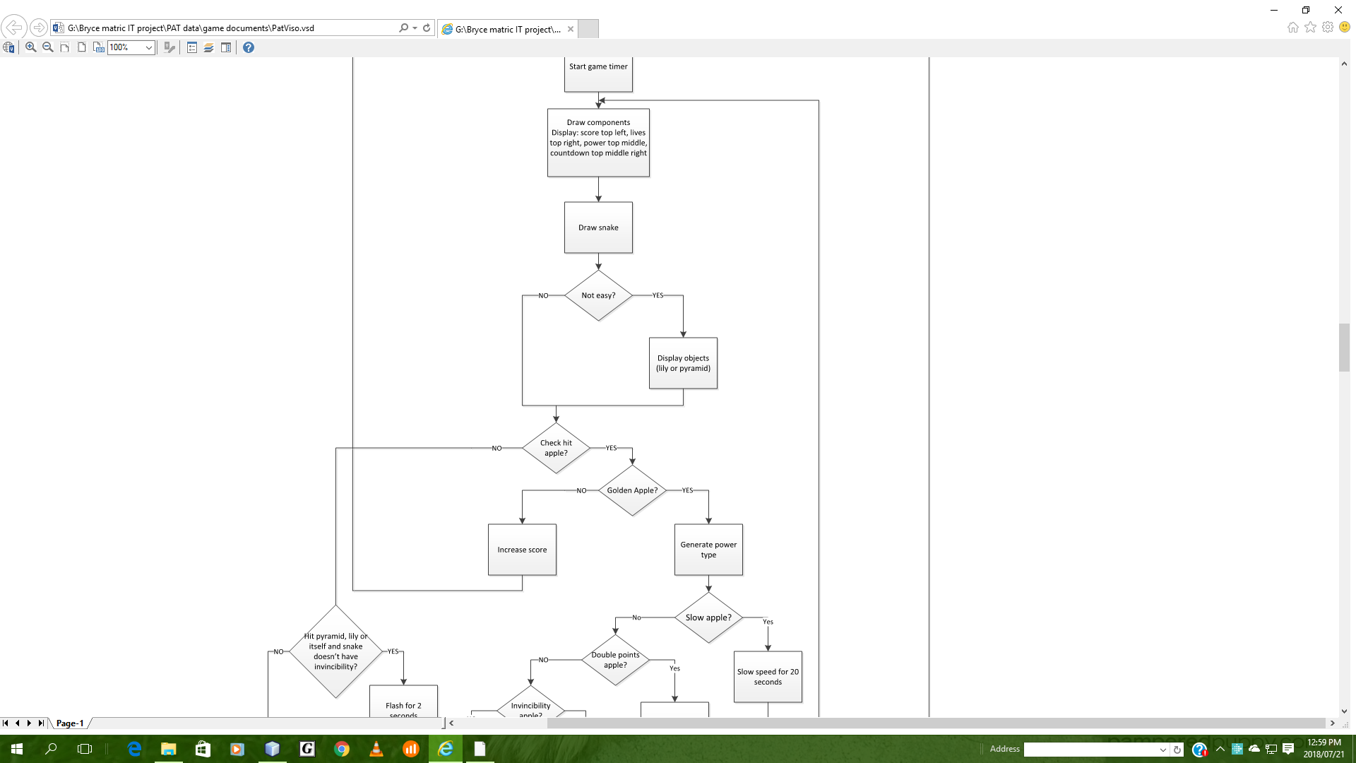

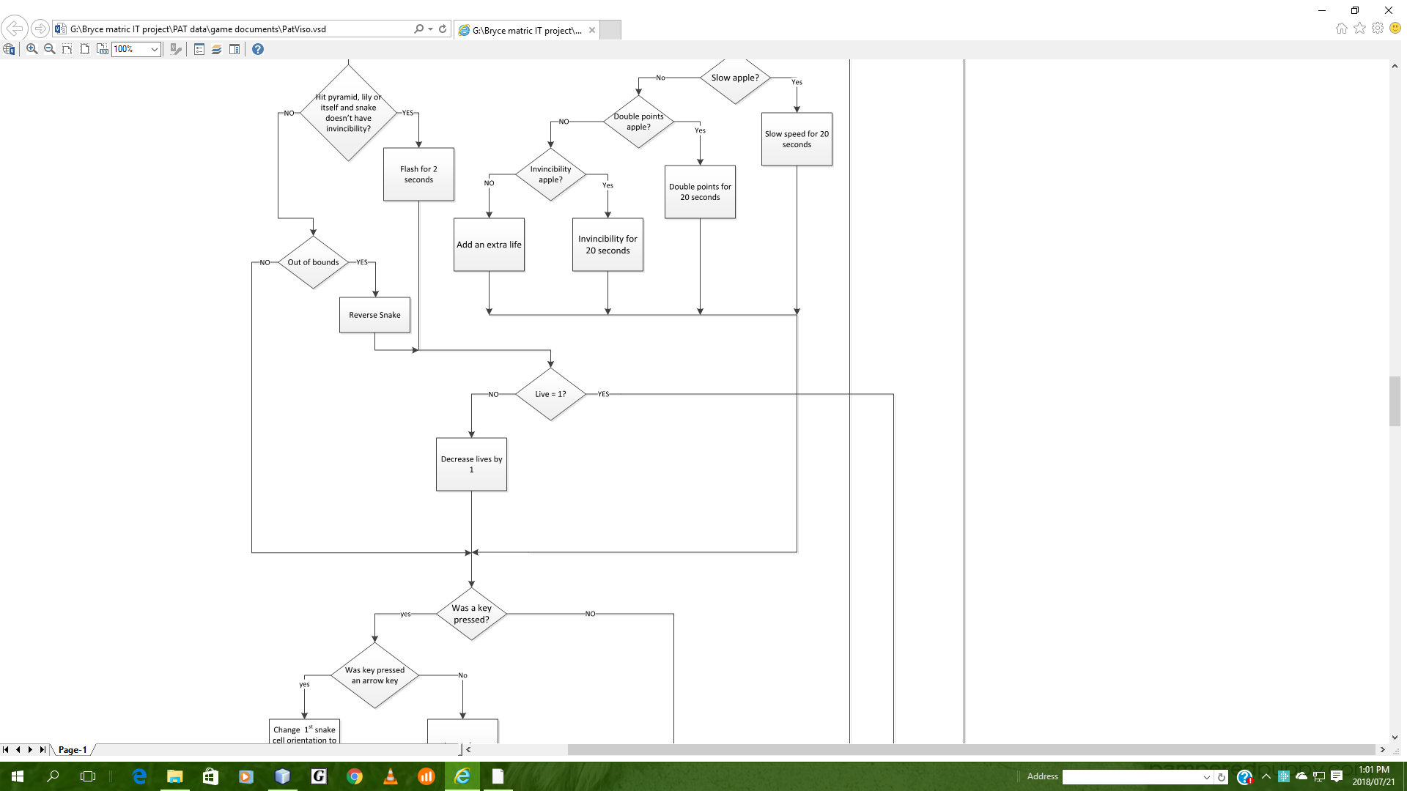

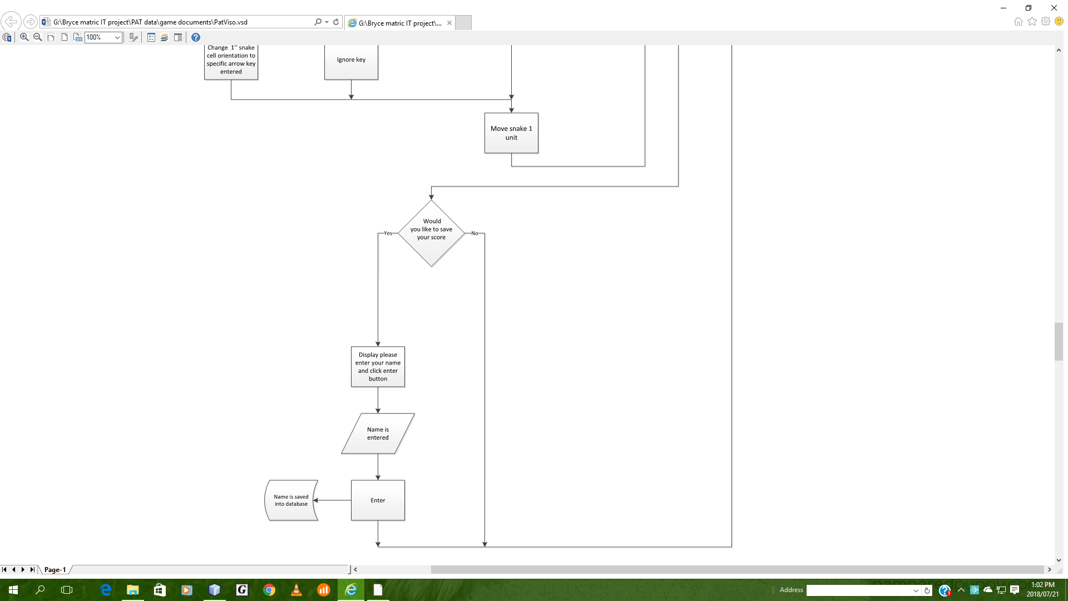

# Classes and internal data storage structures:

|  |  |
| --- | --- |
| Class Name: | GameBoard |
| Properties: | - final int gridSize = 900;  - final int randAppleXValue = 63;  - final int randAppleYValue = 32;  - final int numOfLily = 45;  - final int numOfPyramids = 35;  - final int numOfWall = 140;  - final int xArr[] = new int[gridSize];  - final int yArr[] = new int[gridSize];  - final int objectXArr[] = new int[numOfWall];  - final int objectYArr[] = new int[numOfWall];  - final int gameWidth = 1600;  - final int gameHeight = 900;  - final int unitSize = 25;  - final int powerUpProbability = 8;  - final int powerProbability = 4;  - Timer gameTimer;    - Image unitImage;  - Image appleImage;  - Image headImage;  - Image goldenAppleImage;  - Image snakeHead;  - Image snakeBod;  - Image object;  - boolean upDirec = false;  - boolean downDirec = false;  - boolean leftDirec = false;  - boolean rightDirec = true;  - boolean inGame = true;  - boolean goldenStat = false;  - boolean powerStat = false;  - boolean redo = false;  - boolean redoObject = false;  - boolean invincibility = false;  - boolean doublePoints = false;  - boolean reverse = false;  - boolean countDown = false;  - boolean move = true;  - int appleYPos;  - int appleXPos;  - int numSnakeUnits;  - int goldenYPos;  - int goldenXPos;  - int numObject = 0;  - int rNum = 0;  - int score = 0;  - int lives = 10;  - int timer = 20;  - int delay = 140;  - int speedDelay;  - int usualDelay;  - int tempDelay;  - int flashCount = 2;  - int objectXPos;  - int objectYPos;  - int xPos;  - int yPos;  - String difficulty;  - String what;  - String appleLocation;  - String bodLocation;  - String headLocation;  - String powerMsg = "";  - String appleType = "A";  - useDatabase ud = new useDatabase();  - CountDownTimer t = new CountDownTimer (); |
| Methods: | + GameBoard()  - void addNewGameLayout()    - void addObjects(int num, String image)    - void locateObject()    - void checkObjectTrue()    - void loadSnakeImages()    - Void loadAppleImages()  - void beginGame()  - void locateTheApple()  - void checkAppleTrue()  - void chooseGoldenApple()  - void paintComponent(Graphics g)    - void draw(Graphics g, String text, int x, int y)    - void drawCountDown(Graphics g)  - void initiateDrawing(Graphics g)    - void flash(Image h, Image b)  - void endGame(Graphics g)  + void actionPerformed(ActionEvent e)  - void checkHitApple()    - void checkHitGoldenApple()    - void powerType()  - void changeSpeed()  - void checkHit()  - void changeTimer(int newDelay)  - void moveSnake  - void reverseSnake()    - class TAdapter extends KeyAdapter    + void keyPressed(KeyEvent e) |

|  |  |
| --- | --- |
| Class Name: | SnakeMain |
| Properties: |  |
| Methods: | * SnakeMain() |

|  |  |
| --- | --- |
| Class Name: | CountDownTimer |
| Properties: | - int counter; |
| Methods: | + CountDownTimer()  + void startTimer()  + int getTime() |

|  |  |
| --- | --- |
| Class Name: | UseDatabase |
| Properties: | - Database database = new Database("HighScoreDatabase"); |
| Methods: | + String displaytblHighScore(String difficulty)  + void UpdateTable(String name)    + void InsertData(int id, int score1, String difficulty, String stat, String closeGame)  + void UpdateScore(int score)  + void updateWhat(String what, String value)  + void deleteData()  + int fetchScore()  + String fetchWhat(String what) |

|  |  |
| --- | --- |
| Class Name: | Database |
| Properties: | + static Connection connection;  - PreparedStatement statement;  - ResultSet resultSet;  + Connection conn; |
| Methods: | + Database(String databaseName)  + ResultSet query(String stmt)  + void change(String changeIn) |

# Text file and database:

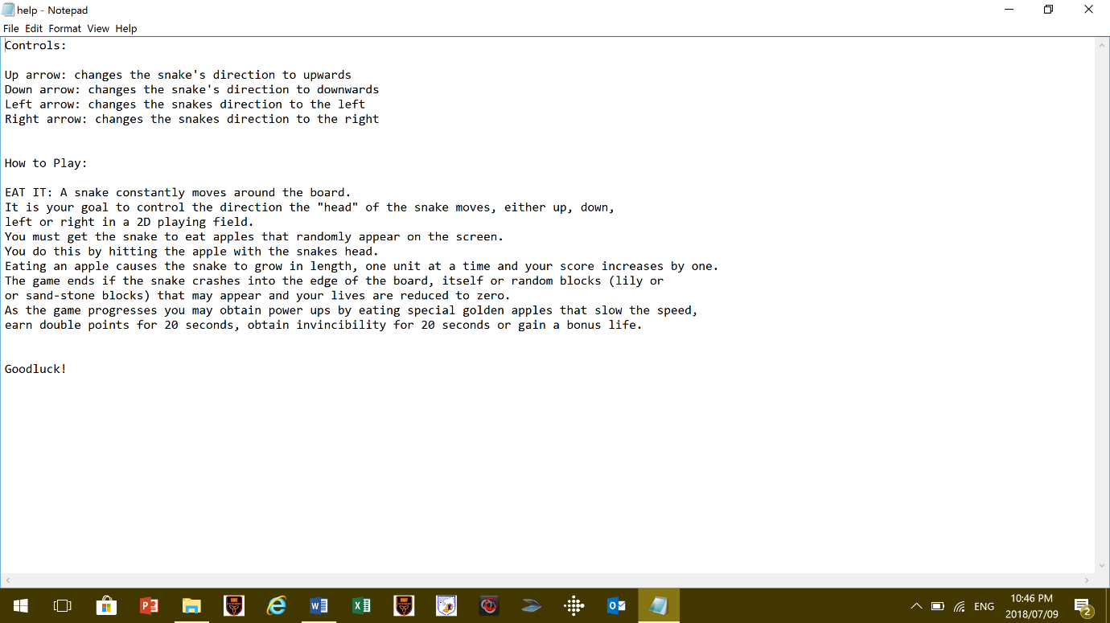Text File

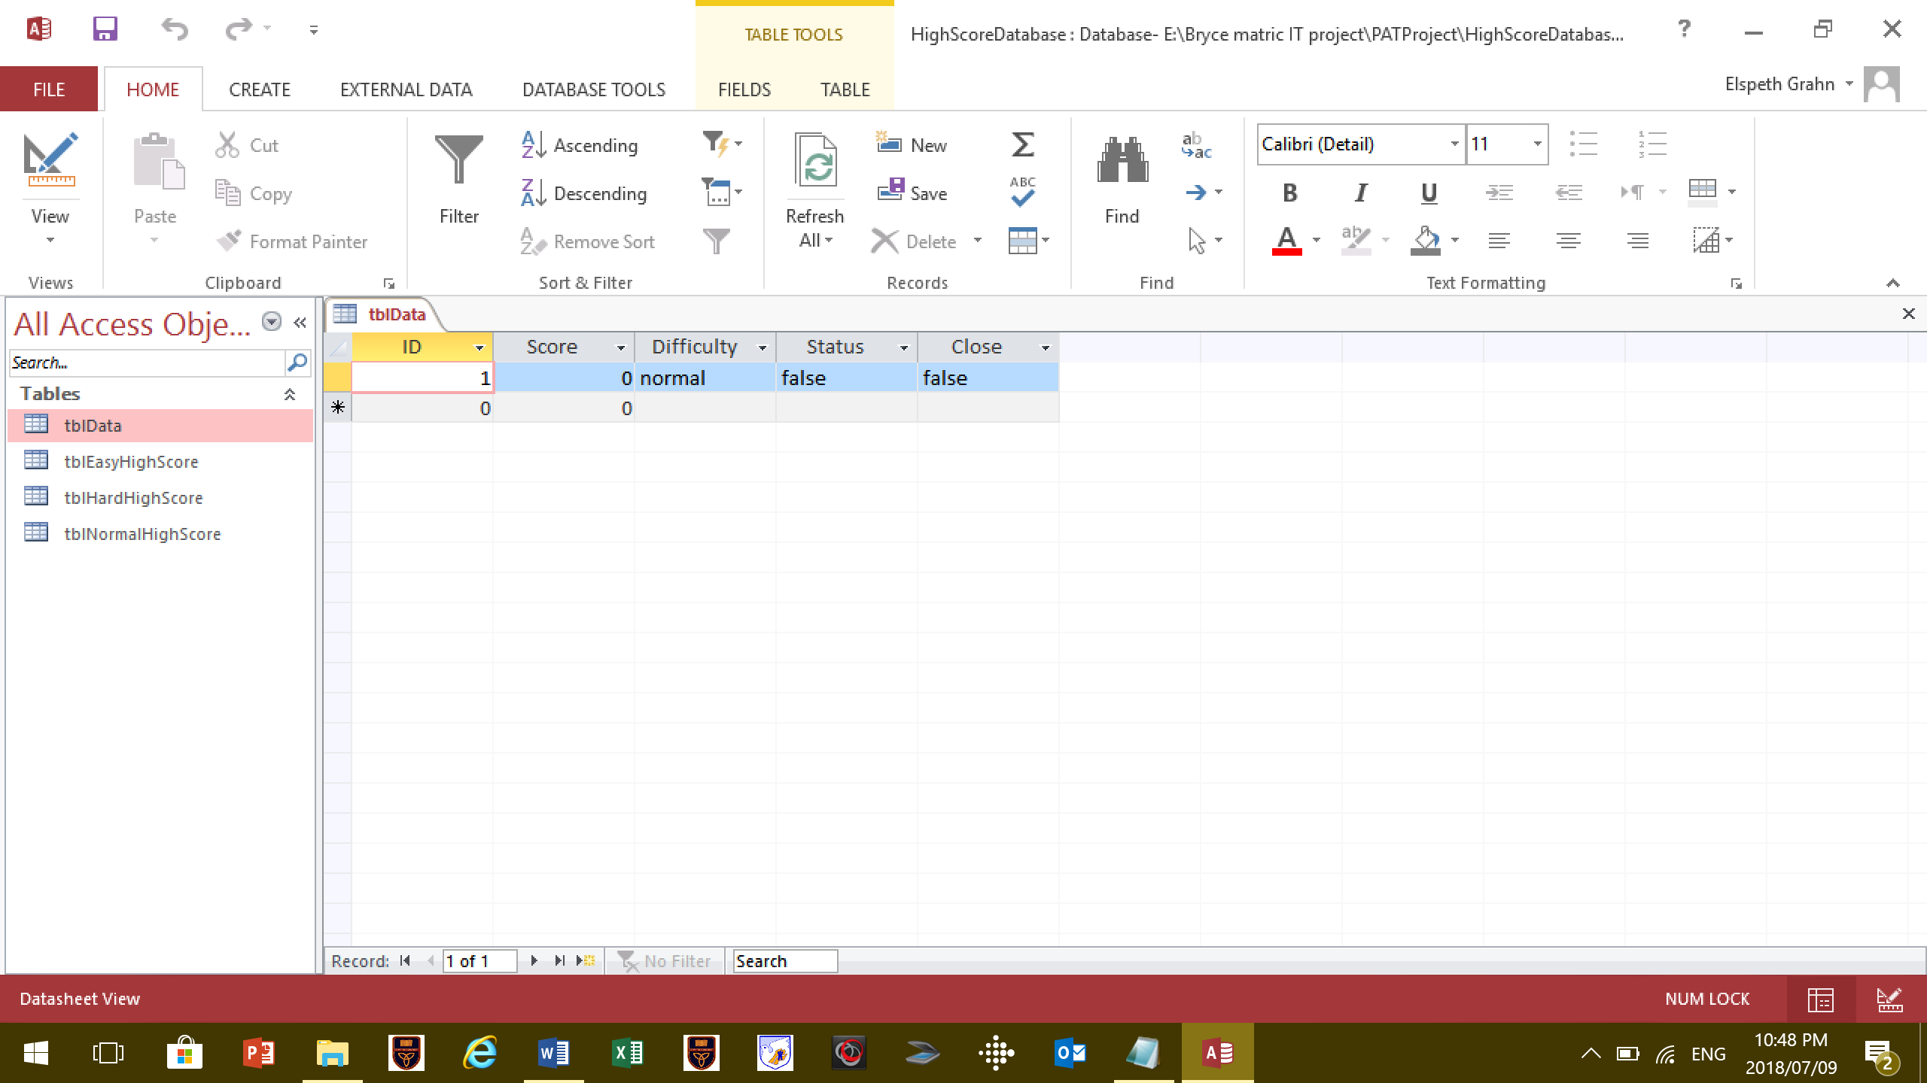Database:

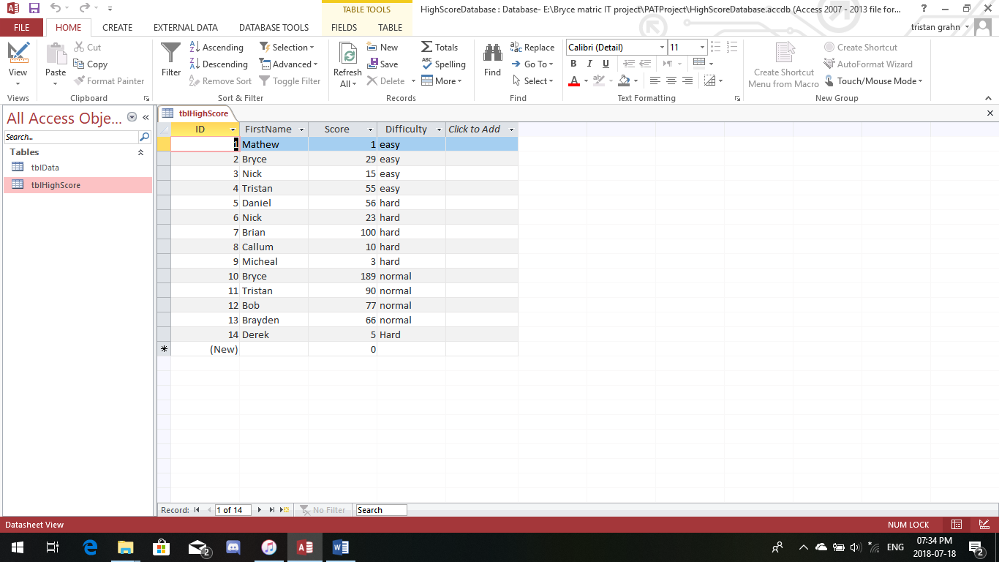

# Reason for storage plan

High-score database:

* Was chosen to store a player’s name with his/her corresponding score so when using SQl statements the top 20 players can be determined and displayed.
* It’s extremely secure
* Has various level accesses
* It is neatly sorted and easy to operate.
* SQL statements can be used to sort and fetch details that are to be displayed

Text file/notepad

* Was used to store the text help information permanently.
* Wraps text neatly and in correct format
* Glorified word processor
* Simple and perfect for storing txt based information
* Information can easily be fetched by the program

Test Plan:

|  |  |  |  |
| --- | --- | --- | --- |
| **component** | **Standard** | **Extreme** | **Abnormal** |
| Jbutton | Click on the middle region of the button | Click on the edge of the button | Click off the button (the back-round of the interface) |
| jTextField | String between 2 characters and 15 (eg first name) | * 1 character in length * 30 characters in length | * Left blank * Contains numbers * String with special characters |
| jRadioButton | yes | no | Left blank or try click both options |
| Keyboard arrow keys | * Up arrow * Down arrow * Left arrow * Right arrow | * Click same arrow repetitively * Abnormal rate of clicking the arrow keys such as 5 times per second | * Click any key except the arrow keys (eg: esc) * Hold key in |